The 2021 AHEPA Golden Gate District Lecture Series
Saturday, January 16th 2pm (PST)  Evangelos Simoudis, Ph.D.  “Transportation Transformation: Our Driverless Future”  https://www.linkedin.com/in/evangelossimoudis/ | 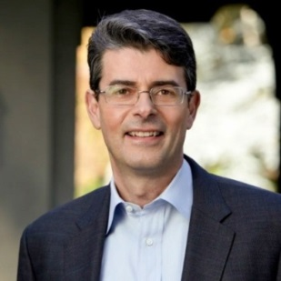
Saturday, February 20th 2pm (PST)  Themi Demas, Ph.D.  “WITH KNOWLEDGE AND VIRTUE: To Save the Earth from Global Warming and Nuclear Weapons”  https://www.linkedin.com/in/themi-demas-bb50a43/ | 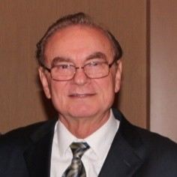
Saturday, March 20th 2pm (PST)  Sokratis Sourvinos,  Consul General of Greece in San Francisco  “200 years since the Uprising of March 25th, 1821 and our National Independence”  https://www.linkedin.com/in/socrates-sourvinos-34327710/ | 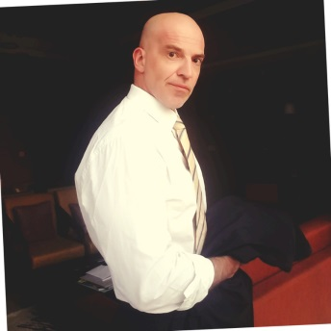
Saturday, April 17th 2pm (PST)  Alexander Kitroeff,  Professor of History at Haverford College  "The Greek Orthodox Church in America A Modern History"  https://www.linkedin.com/in/alexander-kitroeff-9057ab167/ | 